|  |  |  |
| --- | --- | --- |
|  | **Newton’s Laws of Motion** | |
| **Date:** | **Name:** |

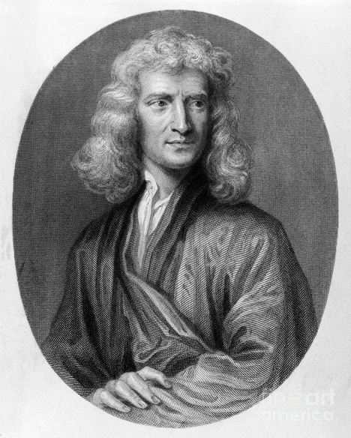

|  |
| --- |
|  |
|  |
|  |

|  |  |  |  |
| --- | --- | --- | --- |
|  | **Newton’s First Law of Motion** | | |
| **And Force Diagrams** |  |

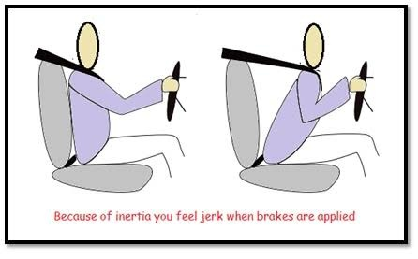

1. Define Inertia.
2. Explain normal force, with the help of an example.
3. Draw labelled force system (or free body) diagrams and determine the net force of the following.
4. A rocket ship before lift-off (at rest).

*Net force:*

1. Two year 10 students pushing on a box on a frictionless surface, one from the left with 15 N of force and one from the right with 25 N of force.

*Net force:*

1. Draw a force diagram for a car driving at a constant velocity (without known values).
2. The car is now merging onto the highway in a straight line. Draw a force diagram showing changes to net force if the car accelerates from its constant speed of 60km/h to 100km/h.
3. Create a velocity / time graph to show the motion of the car if it took the car 10 seconds to reach 100km/h from 60km/h (at a constant rate of acceleration).



1. Calculate the rate of acceleration of the car in the scenario above.
2. Using your graph determine the speed of the car after 7 seconds.
3. A space probe is drifting to the right at a constant velocity in deep interstellar space—far from any influence due to planets and stars—with its rockets off. If two rocket thrusters both turn on simultaneously exerting identical forces leftward and rightward in the directions shown, what would happen to the motion of the rocket? And why?
4. In our everyday lives on Earth, we observe that objects in motion eventually come to rest. Use an example of this occurrence to explain why the object does not remain in motion.
5. A 4.0kg object is moving across a friction-free surface with a constant velocity of 2m/s. Which one of the following horizontal forces is necessary to maintain this state of motion?

|  |  |  |  |
| --- | --- | --- | --- |
| a. 0 N | b. 0.5 N | c. 2.0 N | d. 8.0 N |
| e. depends on the speed. | | | |

1. *Read page 385 of the Pearson textbook. In the Newton’s first law section on the first page of your booklet summarise Newton’s first law.*

|  |  |
| --- | --- |
|  | **Newton’s Second Law of Motion** |
|

*Read Pages 386 to 388 in the Pearson 10 text book. Fill out the Newton’s Second Law section on the first page of your booklet with the definition for Newton’s Second Law and complete the calculation triangle.*

1. Compete the ‘try yourself’ questions 1 and 2 on page 388 of the textbook. Show your working below:

|  |  |
| --- | --- |
|  |  |

1. Complete the following table:

|  |  |  |
| --- | --- | --- |
| *Variable* | *Symbol* | *Unit* |
| Force |  |  |
|  | a |  |
|  |  | Kg |

1. Explain using a diagram how to convert milligrams into grams, grams into kilograms, and kilograms into tones and vice versa.
2. Complete the following table:

|  |  |  |
| --- | --- | --- |
| *Mass* | *Acceleration (m/s2)* | *Force (N)* |
|  | 3.5 | 7.0 |
| 5.5 kg |  | -11 |
| 4.0 kg | 3.0 |  |
| 10.0 kg |  | 55 |
|  | 1.0 | 0.5 |
| 2000 mg |  | 7 |
| 1.5 t | 4.0 |  |

1. Use the correct equation to complete each of the following tasks.
2. If a 1200kg car accelerates at 3.0 m/s2, calculate the force supplied by its engine.

*Unknown variable: _________*

*Known variables (with values): ____ = _________, ______ = _________*

*Equation: ___________________*

*Working out:*

1. Sarah accelerates at 8.0 m/s2 as she starts running in a race. Given that her legs supply a force of 472 N, Calculate Sarah mass.
2. The engine of a train of mass 250,000 kg, supplies a force of 1, 525, 000 N as it leaves a station. Ignoring the effects of friction, calculate the acceleration of the train.
3. Given that a falling stone will accelerate at 9.8 m/s2, what is the size of the weight force that pulls the stone to Earth if the stone has a mass of 0.1kg.

|  |  |
| --- | --- |
|  | **Newton’s Third Law of Motion** |
|

*Read Page 389 in the Pearson 10 text book. Fill out the Newton’s Third Law section on the first page of your booklet with the definition for Newton’s Third Law and an example of an action-reaction force pair.*

1. Use your knowledge of Newton’s Third Law to unpack the following statement;

*“Forces always occur in pairs.”*

1. Identify the action-reaction force pairs for the following situations:
2. Leaning against a wall
3. Walking
4. Kicking a football
5. Hitting a ball with a bat a racquet
6. Explain how you apply Newton’s Laws of motions in your everyday life (give examples)
7. Use the words below in sentences. Use the words to describe another word if you can!

|  |  |
| --- | --- |
| Inertia | Force |
| Acceleration | Mass |
| Net force | Weight |
| Action-reaction |  |

*e.g. The* ***mass*** *of an object affects the* ***force*** *needed to* ***accelerate*** *the object.*

|  |  |  |  |  |  |  |
| --- | --- | --- | --- | --- | --- | --- |
|  |  |  |  |  |  |  |
|  |  |  |  |  |  |  |
|  |  |  |  |  |  |  |
|  |  |  |  |  |  |  |
|  |  |  |  |  |  |  |
|  |  |  |  |  |  |  |
|  |  |  |  |  |  |  |
|  |  |  |  |  |  |  |
|  |  |  |  |  |  |  |
|  |  |  |  |  |  |  |
|  |  |  |  |  |  |  |
|  |  |  |  |  |  |  |
|  |  |  |  |  |  |  |
|  |  |  |  |  |  |  |
|  |  |  |  |  |  |  |
|  |  |  |  |  |  |  |
|  |  |  |  |  |  |  |
|  |  |  |  |  |  |  |
|  |  |  |  |  |  |  |
|  |  |  |  |  |  |  |
|  |  |  |  |  |  |  |
|  |  |  |  |  |  |  |
|  |  |  |  |  |  |  |
|  |  |  |  |  |  |  |
|  |  |  |  |  |  |  |
|  |  |  |  |  |  |  |